**Chapter 6: Applications of Definite Integrals**

Table of Contents

6.1 Volume Using Cross-Sections 2

6.3 Arc Length 9

6.4 Areas of Surfaces of Revolution 13

## 6.1 Volume Using Cross-Sections

Volume, $V=area×height=A×h$

For rotation about $x$-axis, volume by disks is used.

$$a$$

$$b$$

Volume $=\int_{a}^{b}{A\left(x\right)dx}=π\int_{a}^{b}{{\left[f\left(x\right)\right]}^{2}dx}$

For rotation about $y$-aaxis,

$$a$$

$$b$$

$$V=π\int_{a}^{b}{{\left[f\left(y\right)\right]}^{2}dx}$$

Example 4

The region between the curve $y=\sqrt{x}$, $0≤x≤4$, and the $x$-axis is revolved about the $x$-axis to generate a solid. Find its volume.

$$V=π\int_{a}^{b}{{\left[f\left(x\right)\right]}^{2}dx}$$

$$=π\int_{0}^{4}{{\left(\sqrt{x}\right)}^{2}dx}$$

$$=π{\left[\frac{x^{2}}{x}\right]}_{0}^{4}$$

$$=8π units^{3}$$

Example 5

The circle $x^{2}+y^{2}=4^{2}$ is rotated about the $x$-axis to generate a sphere. Find its volume.

$y=\sqrt{4^{2}-x^{2}}$ $y=0$ $x=±4$

$$V=π\int_{a}^{b}{{\left[f\left(x\right)\right]}^{2}dx}$$

$$=π\int_{-4}^{4}{\left(4^{2}-x^{2}\right)dx}$$

$$=π{\left[16x-\frac{x^{3}}{3}\right]}_{-4}^{4}$$

$$=\frac{256}{3}π units^{3}$$

Volume by Washers for Rotation About the $X$-Axis

$$a$$

$$b$$

$V_{1}=π\int_{a}^{b}{{\left[f\left(x\right)\right]}^{2}dx}$ $V_{2}=π\int_{a}^{b}{{\left[g\left(x\right)\right]}^{2}dx}$

$$V=π\int_{a}^{b}{\left[{\left\{f\left(x\right)\right\}}^{2}-{\left\{g\left(x\right)\right\}}^{2}\right]dx}$$

Example 9

The region bounded by the curve $y=x^{2}+1$ and the line $y=-x+2$ is revolved about the $x$-axis to generate a solid. Find the volume of the solid.

$$y=x^{2}+1=-x+3$$

$$x^{2}+x-2=0$$

$$x=1, -2$$

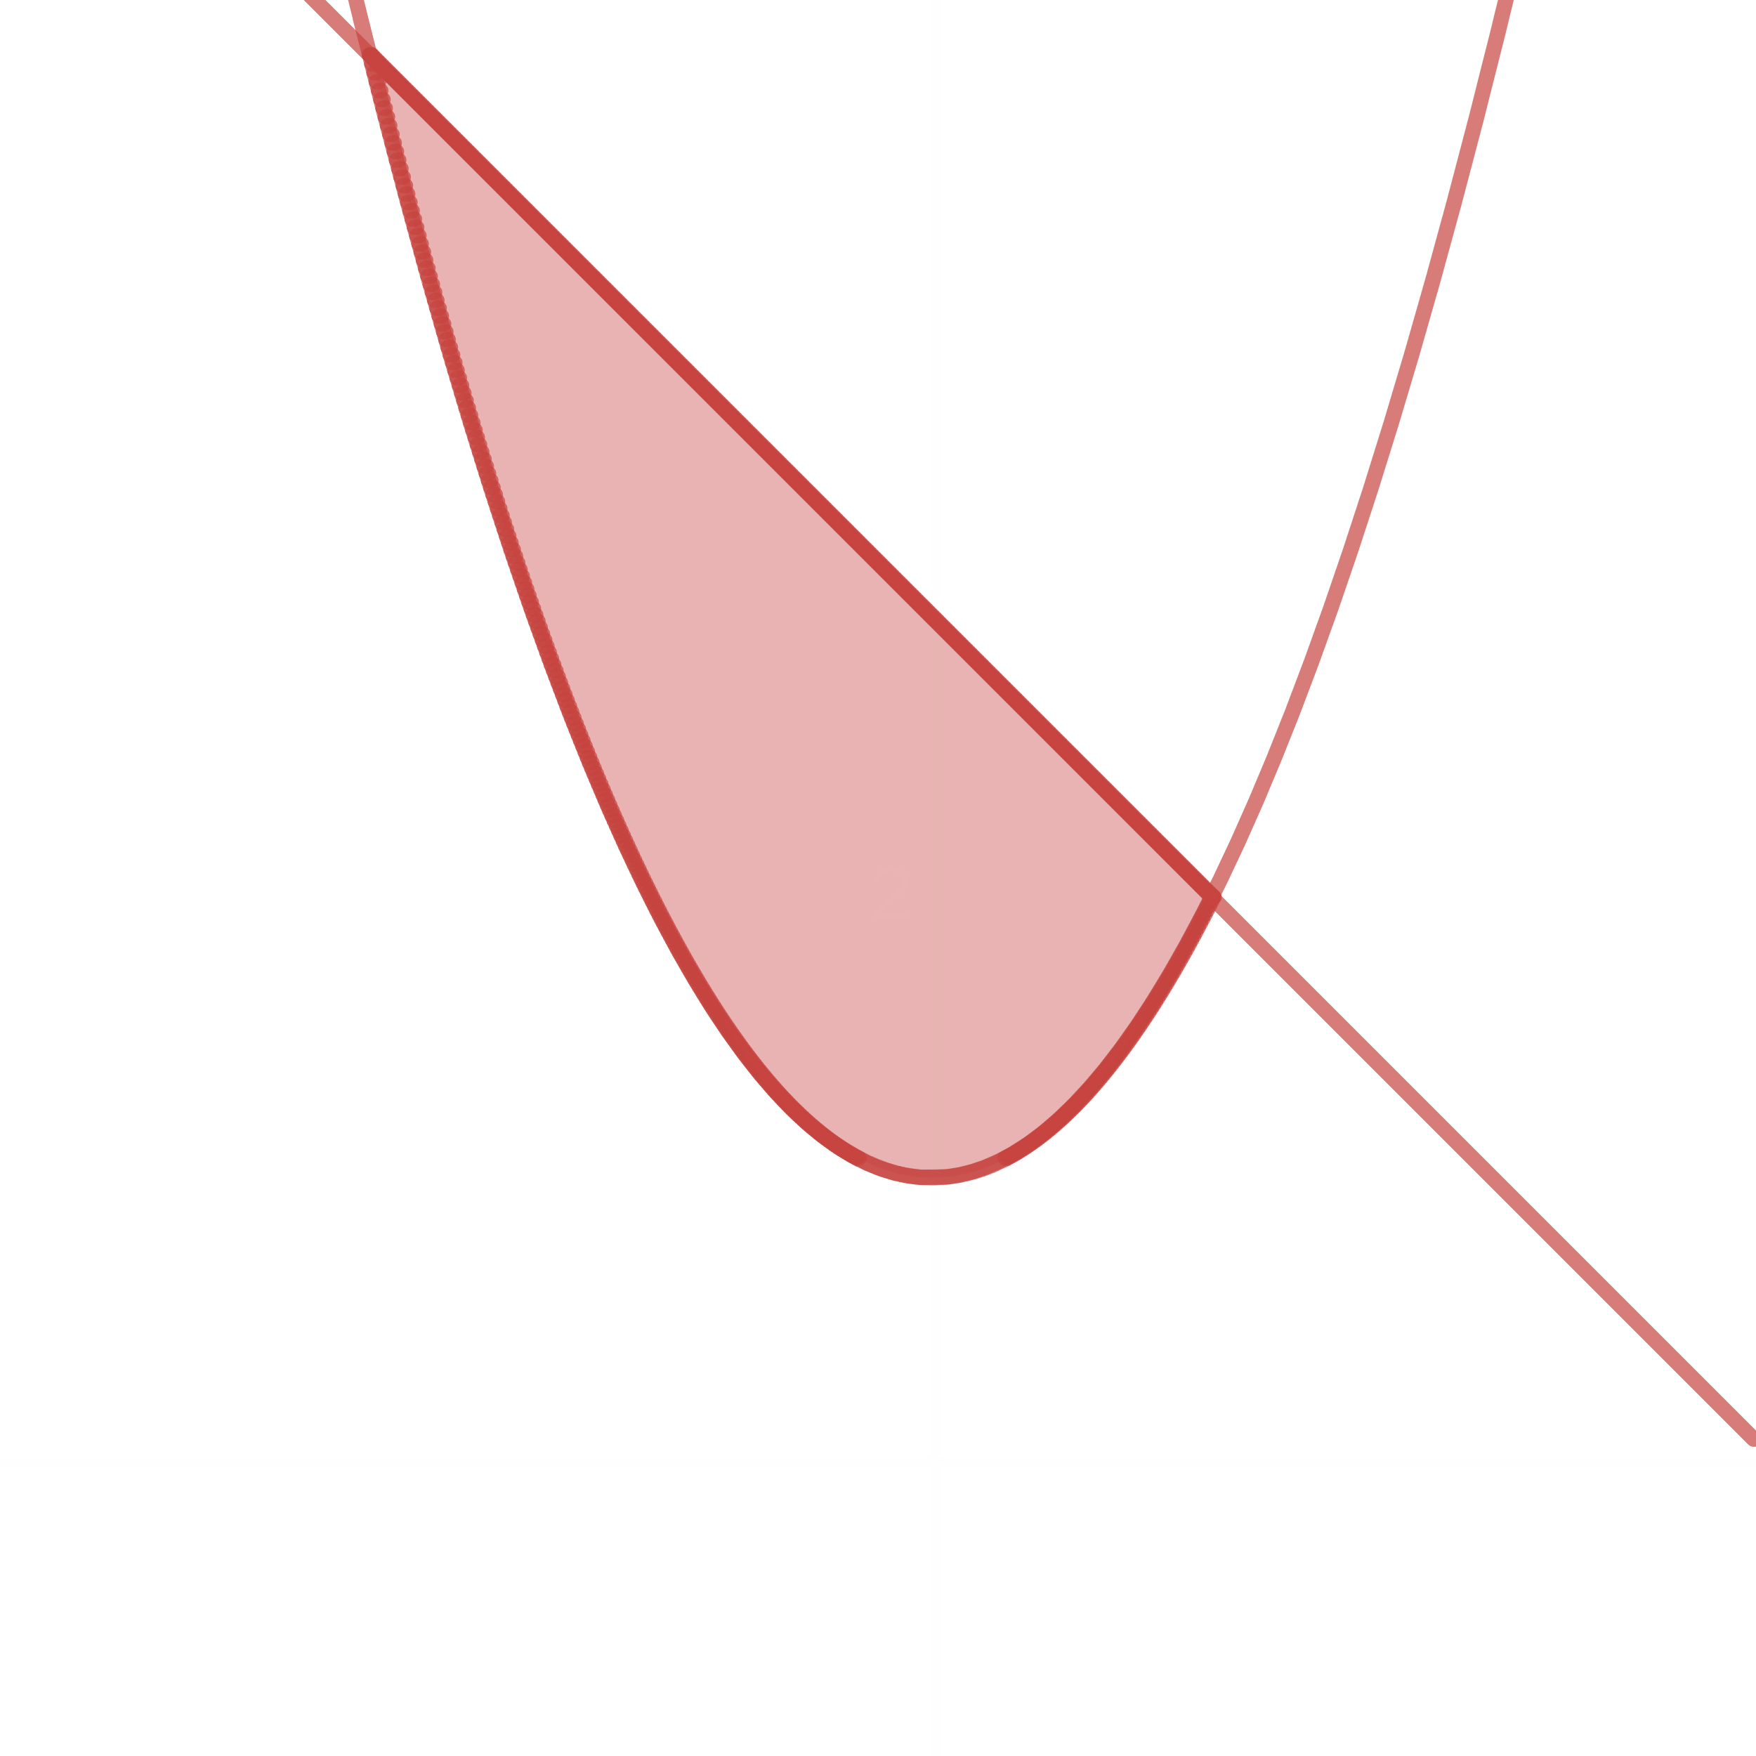

The region is bounded above by the line $y=-x+3$, below by the curve $y=x^{2}+1$, on the left by $x=-2$ and on the right by $x=1$. Thus, the outer radius is $y=-x+3=f\left(x\right)$ and the inner radius is $y=x^{2}+1=g\left(x\right)$.

Volume $=π\int_{a}^{b}{\left[{\left\{f\left(x\right)\right\}}^{2}-{\left\{g\left(x\right)\right\}}^{2}\right]dx}$

$$=π\int_{-2}^{1}{\left[{\left(-x+3\right)}^{2}-{\left(x^{2}+1\right)}^{2}\right]dx}$$

$$=π\int_{-2}^{1}{\left[-x^{4}-x^{2}-6x+8\right]dx}$$

$$=π{\left[-\frac{x^{5}}{5}-\frac{x^{3}}{3}-3x^{2}+8x\right]}_{-2}^{1}$$

$$=\frac{117}{5}π units^{3}$$

Exercise 6.1

Find the volume of the solid generated by revolving the region bounded by

Exercise 19 – 28

Volume by Disk

Exercise 19

$y=x^{2}$ $y=0$ $x=2$

The volume of the region bounded by $y=x^{2}$, $y=0$ and $x=2$ and rotated about the $x$-axis is

$$=π\int_{a}^{b}{{\left[f\left(x\right)\right]}^{2}dx}$$

$$=π\int_{0}^{2}{x^{4}dx}$$

$$=π{\left[\frac{x^{5}}{5}\right]}_{0}^{2}$$

$$=\frac{32}{5}π units^{3}$$

Exercise 23

$y=\sqrt{\cos{x}}$ $0≤x≤\frac{π}{2}$

The volume of the region bounded by $y=\sqrt{\cos{x}}$, $x=0$ and $x=\frac{π}{2}$ and rotated about the $x$-axis is

$$=π\int_{a}^{b}{{\left[f\left(x\right)\right]}^{2}dx}$$

$$=π\int_{0}^{\frac{π}{2}}{{\left(\sqrt{\cos{x}}\right)}^{2}dx}$$

$$=π{\left[\sin{x}\right]}_{0}^{\frac{π}{2}}$$

$$=π units^{3}$$

Exercise 39 – 44

Volume by Washers

Exercise 40

$y=2\sqrt{x}$ $y=2$ $x=0$

$y=2$ $x=1$

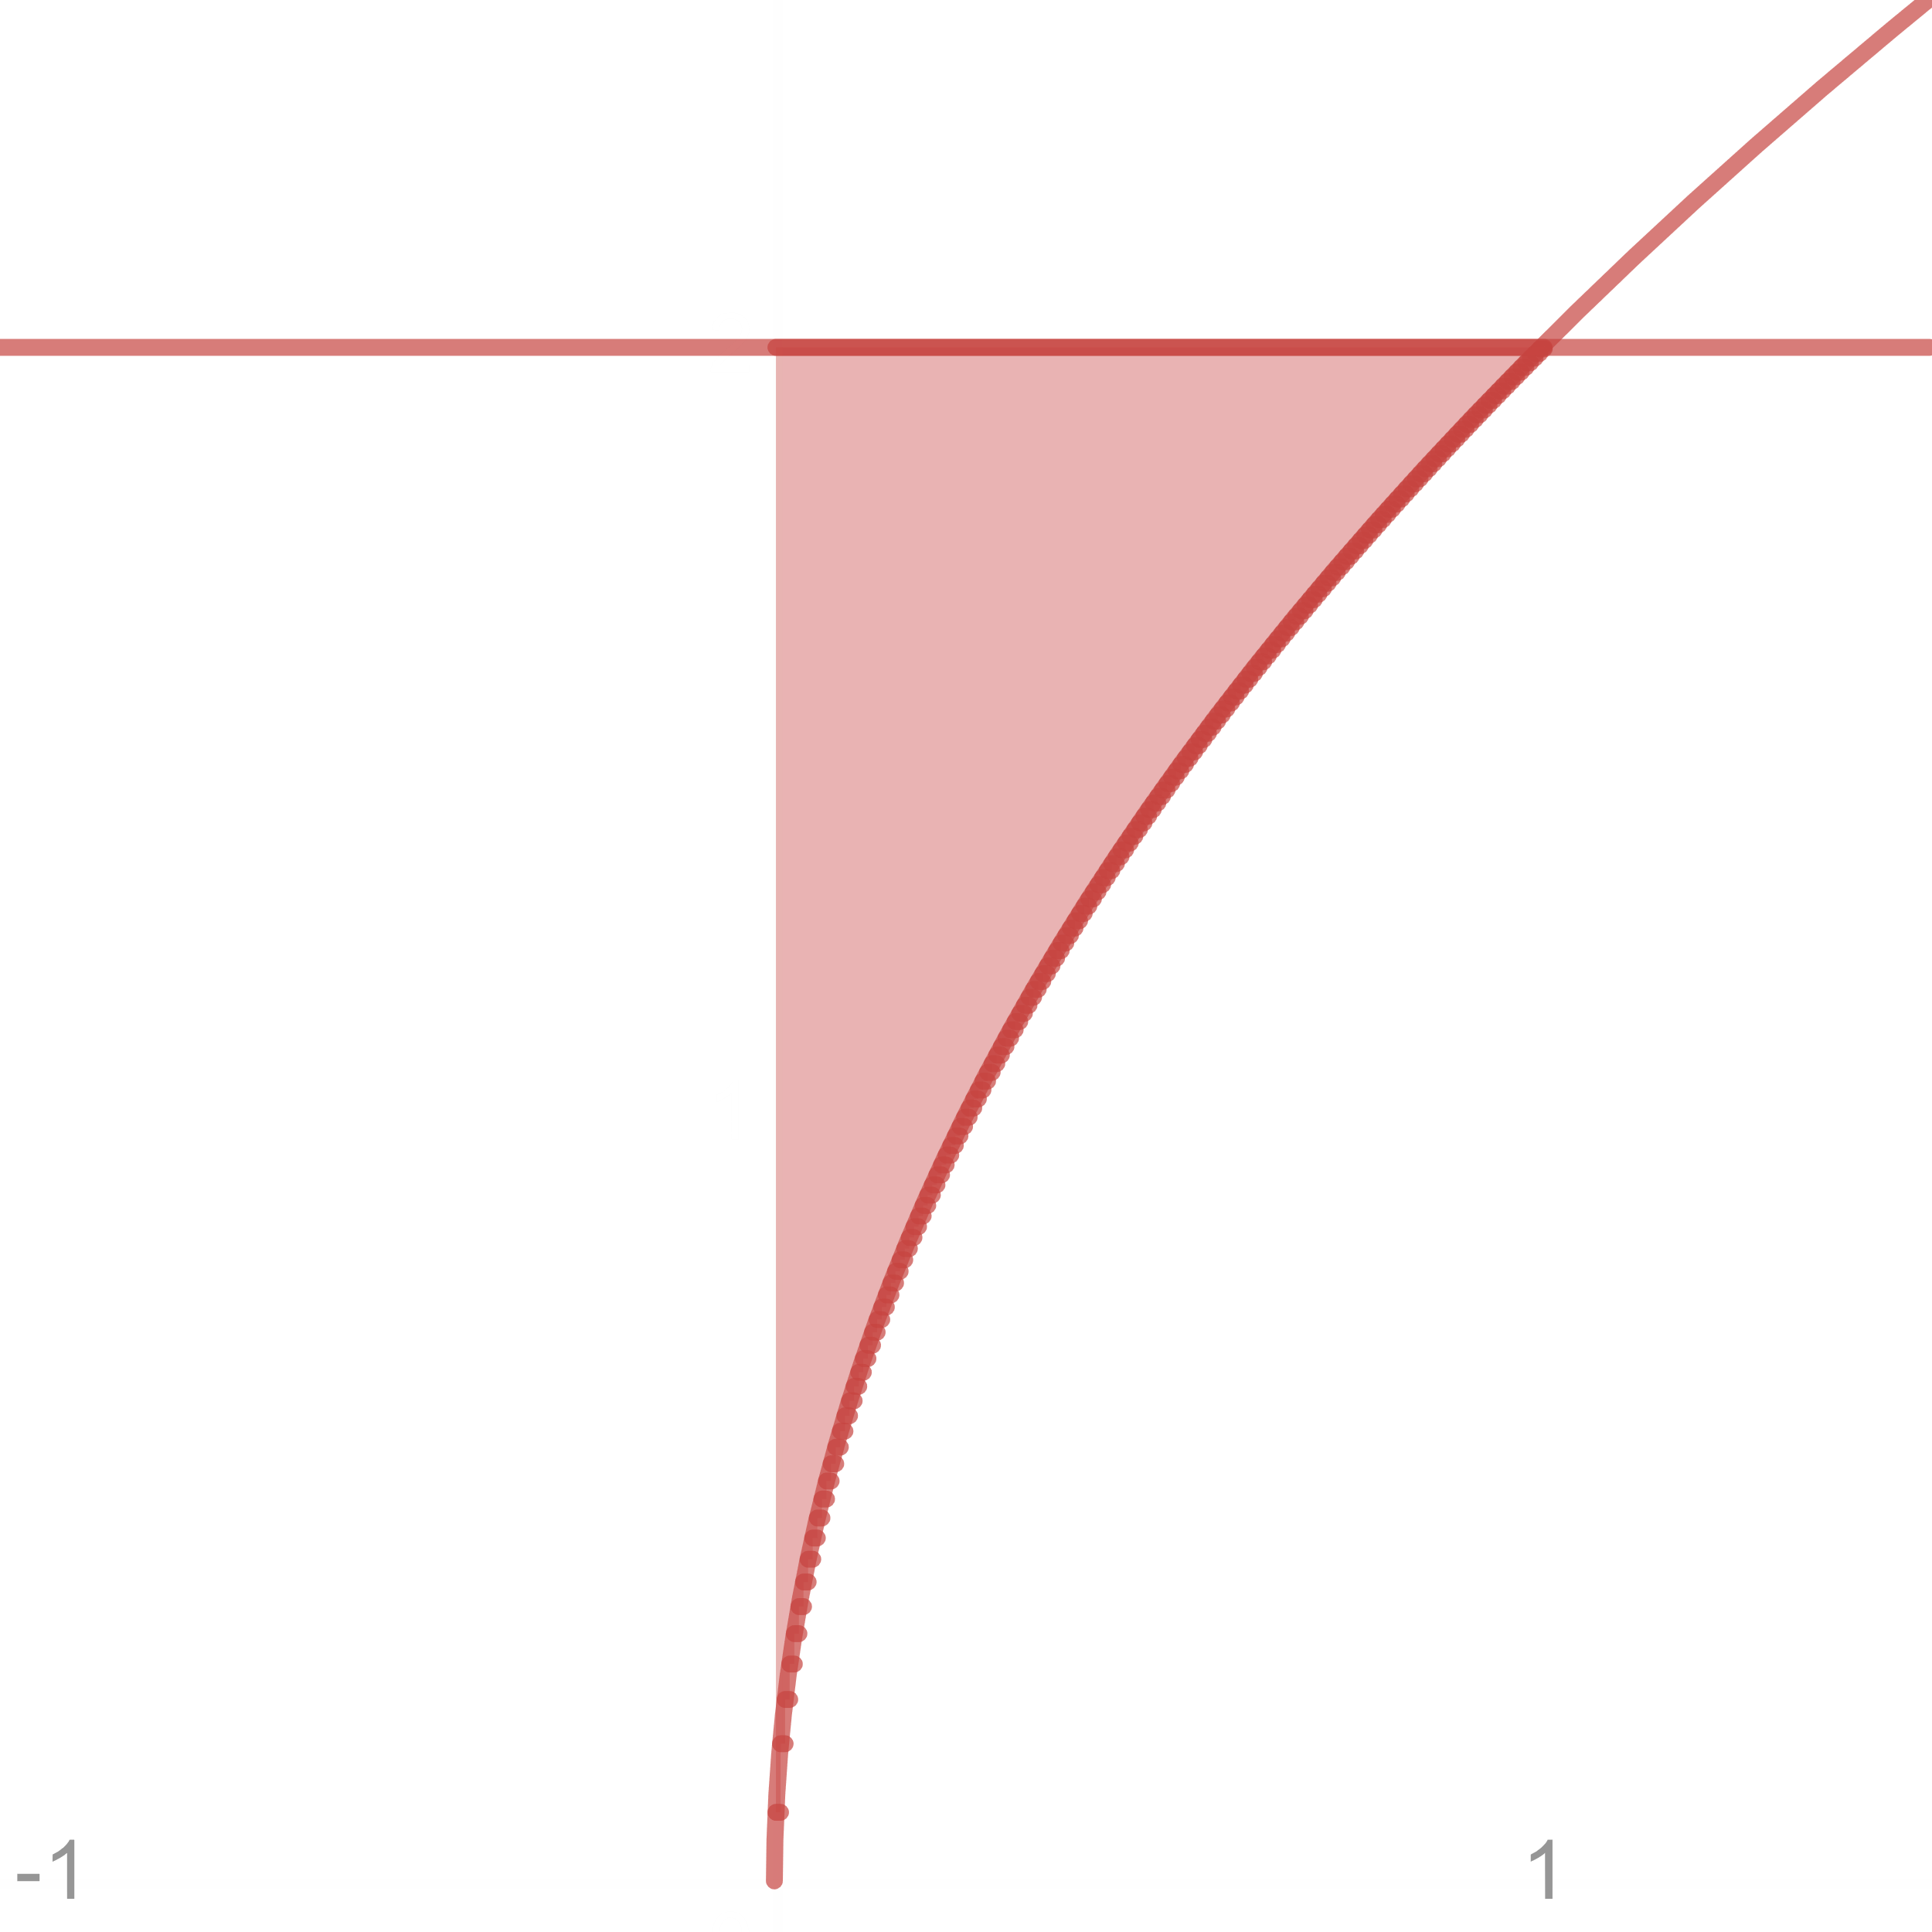

The region is bounded above by the line $y=2$, below by the curve $y=2\sqrt{x}$, on the left by $x=0$ and on the right by $x=1$.

The volume of the region rotated about the $x$-axis is

$$=π\int_{a}^{b}{\left[{\left\{f\left(x\right)\right\}}^{2}-{\left\{g\left(x\right)\right\}}^{2}\right]dx}$$

$$=π\int_{0}^{1}{[2^{2}}-{\left(2\sqrt{x}\right)}^{2}]dx$$

$$=π\int_{0}^{1}{\left(4-4x\right)dx}$$

$$=π{\left[4x-2x^{2}\right]}_{0}^{1}$$

$$=2π units^{3}$$

Exercise 42

$y=4-x^{2}$ $y=2-x$

$$4-x^{2}=2-x$$

$$x^{2}-x-2=0$$

$$x=2, -1$$

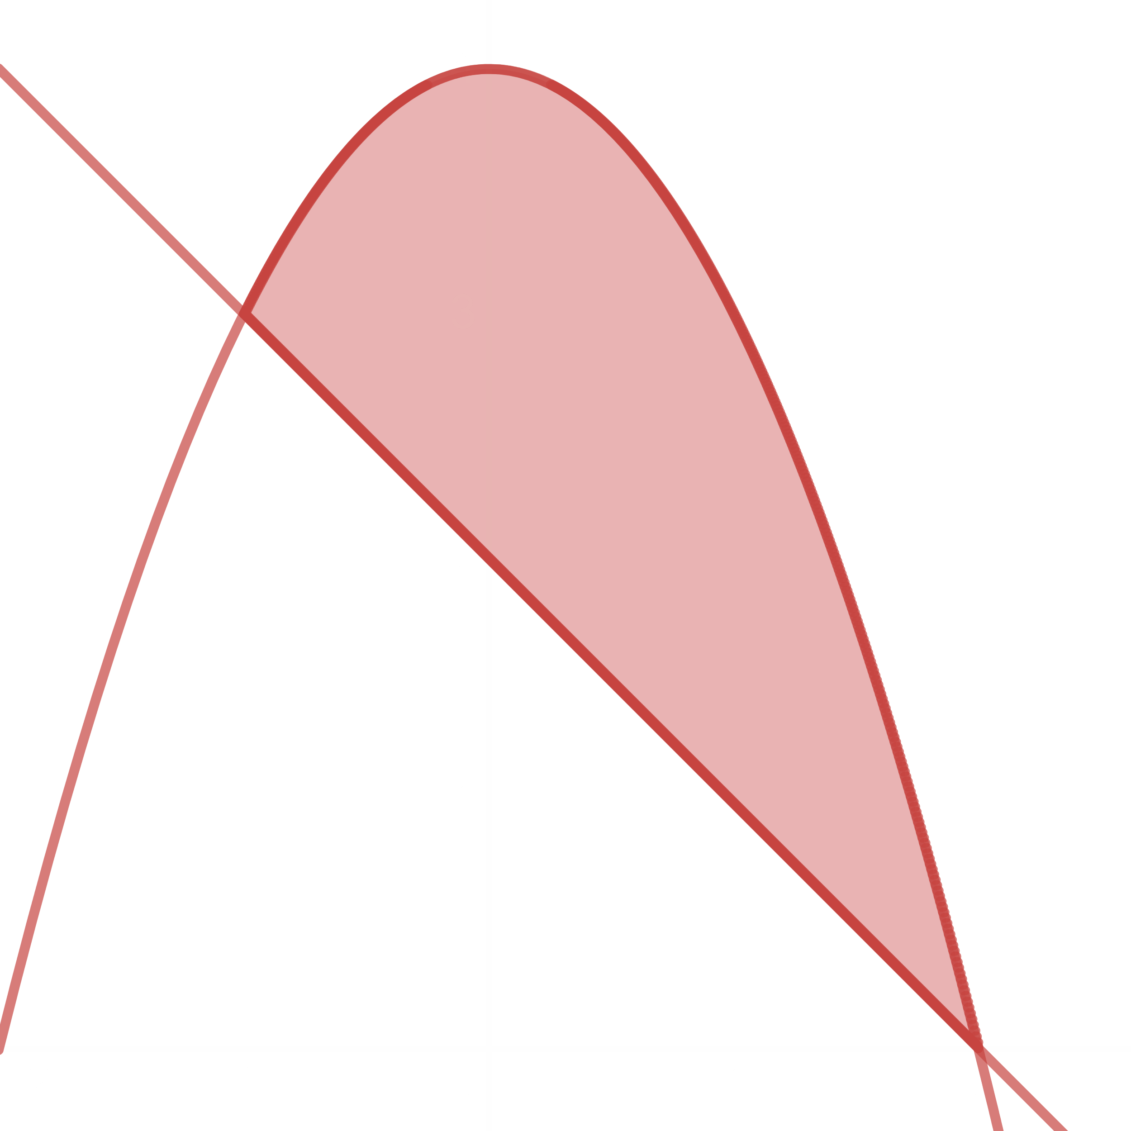

The region is bounded above by the curve $y=4-x^{2}$, below by the line $y=2-x$, on the left by $x=-1$ and on the right by $x=2$.

The volume of the region rotated about the $x$-axis is

$$=π\int_{a}^{b}{\left[{\left\{f\left(x\right)\right\}}^{2}-{\left\{g\left(x\right)\right\}}^{2}\right]dx}$$

$$=π\int_{-1}^{2}{\left[{\left(4-x^{2}\right)}^{2}-{\left(2-x\right)}^{2}\right]dx}$$

$$=π\int_{-1}^{2}{\left(16-8x^{2}+x^{4}-4+4x-x^{2}\right)dx}$$

$$=π{\left[\frac{x^{5}}{5}-3x^{3}+2x^{2}+12x\right]}_{-1}^{2}$$

$$=\frac{108}{5}π units^{3}$$

## 6.3 Arc Length

Arc length of a curve $y=f\left(x\right)$ from the point $\left(a, f\left(a\right)\right)$ to $\left(b, f\left(b\right)\right)$ is given by

$$L=\int_{a}^{b}{\sqrt{1+{\left(\frac{dy}{dx}\right)}^{2}}dx}$$

Similarly, for the curve $x=f\left(y\right)$,

$$L=\int_{a}^{b}{\sqrt{1+{\left(\frac{dy}{dx}\right)}^{2}}dy}$$

Example 1 – 4

Example 3

Find the length of the curve $y=\frac{1}{2}\left(e^{x}+e^{-x}\right)$, $0≤x≤2$.

$$\frac{dy}{dx}=\frac{1}{2}\left(e^{x}-e^{-x}\right)$$

By definition we know,

Arc Length, $L=\int_{a}^{b}{\sqrt{1+{\left(\frac{dy}{dx}\right)}^{2}}dx}$

$$=\int_{0}^{2}{\sqrt{1+{\left\{\frac{1}{2}\left(e^{x}-e^{-x}\right)\right\}}^{2}}dx}$$

$$=\int_{0}^{2}{\sqrt{1+\frac{1}{4}\left(e^{2x}-2+e^{-2x}\right)}dx}$$

$$=\int_{0}^{2}{\frac{\sqrt{4+e^{2x}-2+e^{-2x}}}{2}}dx$$

$$=\int_{0}^{2}{\frac{\sqrt{{\left(e^{x}+e^{-x}\right)}^{2}}}{2}dx}$$

$$={\left[\frac{e^{x}}{2}-\frac{e^{-x}}{2}\right]}_{0}^{2}$$

$$=\frac{e^{2}}{2}-\frac{1}{2e^{2}}-\frac{1}{2}+\frac{1}{2}$$

$$=\frac{e^{4}-1}{2e^{2}}$$

Exercise 1 – 10

Exercise 2

$y=x^{\frac{3}{2}}$ from $x=0$ to $x=4$

$$\frac{dy}{dx}=\frac{3}{2}x^{\frac{1}{2}}$$

Arc Length, $L=\int_{a}^{b}{\sqrt{1+{\left(\frac{dy}{dx}\right)}^{2}}dx}$

$$=\int_{0}^{4}{\sqrt{1+{\left(\frac{3}{2}x^{\frac{1}{2}}\right)}^{2}}dx}$$

$$=\int_{0}^{4}{\sqrt{1+\frac{9}{4}x}dx}$$

Let $z=1+\frac{9}{4}x$

$$dz=\frac{9}{4}dx$$

$x=4$ $z=10$

$x=0$ $z=1$

$$\int_{1}^{10}{\frac{4}{9}\sqrt{z}}dz$$

$$=\frac{4}{9}{\left[\frac{2}{3}z^{\frac{3}{2}}\right]}_{1}^{10}$$

$$=9.07$$

Exercise 19 – 20

Exercise 19

a) Find the curve through the point $\left(1, 1\right)$ whose length integral is $L=\int_{1}^{4}{\sqrt{1+\frac{1}{4x}}dx}$

$${\left(\frac{dy}{dx}\right)}^{2}=\frac{1}{4x}$$

$$\frac{dy}{dx}=\frac{1}{2\sqrt{x}}$$

$$dy=\frac{1}{2\sqrt{x}}dx$$

$$y=\frac{1}{2}\int{\frac{1}{\sqrt{x}}dx}=\sqrt{x}+c$$

$y=1$ $x=1$ $c=0$

$$∴y=\sqrt{x}$$

b) How many curves are there?

One

## 6.4 Areas of Surfaces of Revolution

The area of the surface generated by revolving the graph of $y=f\left(x\right)$ on $\left[a, b\right]$ about the $x$-axis is given by

$$S=\int_{a}^{b}{2πy\sqrt{1+{\left(\frac{dy}{dx}\right)}^{2}}dx}$$

$$=\int_{a}^{b}{2πf\left(x\right)\sqrt{1+{\left\{f^{'}\left(x\right)\right\}}^{2}}dx}$$

$$a$$

$$b$$

For $x=f\left(y\right)$,

$$S=\int_{a}^{b}{2πx\sqrt{1+{\left(\frac{dx}{dy}\right)}^{2}}dy}$$

Exercise 13 – 23

Exercise 14

$y=\sqrt{x}$ $\frac{3}{4}≤x≤\frac{15}{4}$ $x$-axis

We know the area of the surface generated by revolving the graph of $y=\sqrt{x}$ on $\left[\frac{3}{4},\frac{15}{4}\right]$ about the $x$-axis is

$$S=\int_{a}^{b}{2πf\left(x\right)\sqrt{1+{\left\{f^{'}\left(x\right)\right\}}^{2}}dx}$$

$$\frac{dy}{dx}=\frac{1}{2\sqrt{x}}$$

$$S=\int_{\frac{3}{4}}^{\frac{15}{4}}{2π\sqrt{x}\sqrt{1+{\left(\frac{1}{2\sqrt{x}}\right)}^{2}}dx}$$

$$=\int_{\frac{3}{4}}^{\frac{15}{4}}{\left(\frac{2π}{2}\sqrt{4x+1}\right)dx}$$

Let $4x+1=z$

$$4dx=dz$$

$x=\frac{15}{4}$ $z=16$

$x=\frac{3}{4}$ $z=4$

$$\int_{4}^{16}{\left(\frac{2π}{8}\sqrt{z}\right)dz}$$

$$=\frac{π}{4}{\left[\frac{2}{3}z^{\frac{3}{2}}\right]}_{4}^{16}$$

$$=\frac{28}{3}π$$

Exercise 9 – 12

Exercise 10

Find the lateral surface area of the core generated by revolving the line segment $y=\frac{x}{2}$, $0≤x≤4$, about the $y$-axis. Check your answer with the geometric formula:

$$Lateral Surface Area= \frac{1}{2}×base circumference×slant height$$

Given, $y=\frac{x}{2}$

$$x=2y$$

$x=0$ $y=0$

$x=4$ $y=2$

$$\frac{dx}{dy}=2$$

We know, the area of the surface generated by revolving the graph of $x=2y$ on $\left[0, 2\right]$ about the $y$-axis is

$$S=\int_{a}^{b}{2πf\left(y\right)\sqrt{1+{\left(\frac{dx}{dy}\right)}^{2}}dy}$$

$$=\int_{0}^{2}{2π2y\sqrt{1+2^{2}}dy}$$

$$=4π\sqrt{5}{\left[\frac{y^{2}}{2}\right]}_{0}^{2}$$

$$=8π\sqrt{5} units^{2}$$

$$2$$

$$4$$

Slant Height $=\sqrt{4^{2}+2^{2}}=2\sqrt{5}$

Base Circumference $=2πr=2π×4=8π$

$$Lateral Surface Area=\frac{1}{2}×base circumference×slant height$$

$$=\frac{1}{2}×8π×2\sqrt{5}$$

$=8π\sqrt{5} units^{2}$ (Proven)